**Step 1: Install and Configure Git**

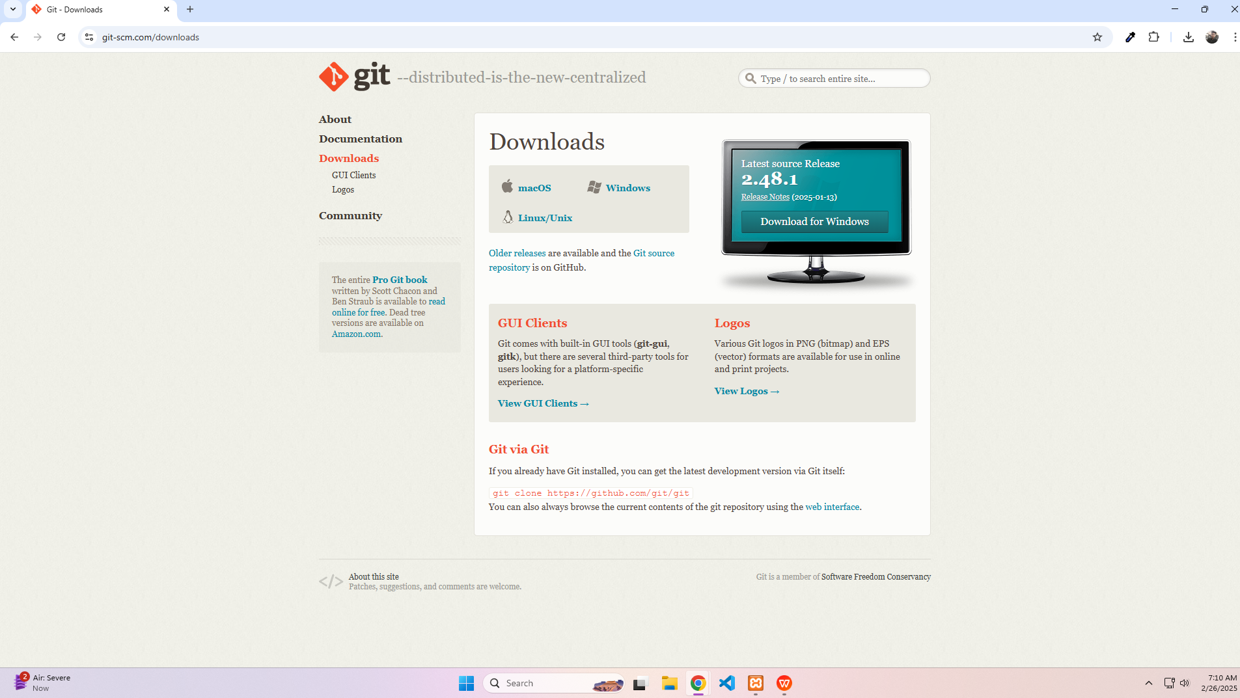

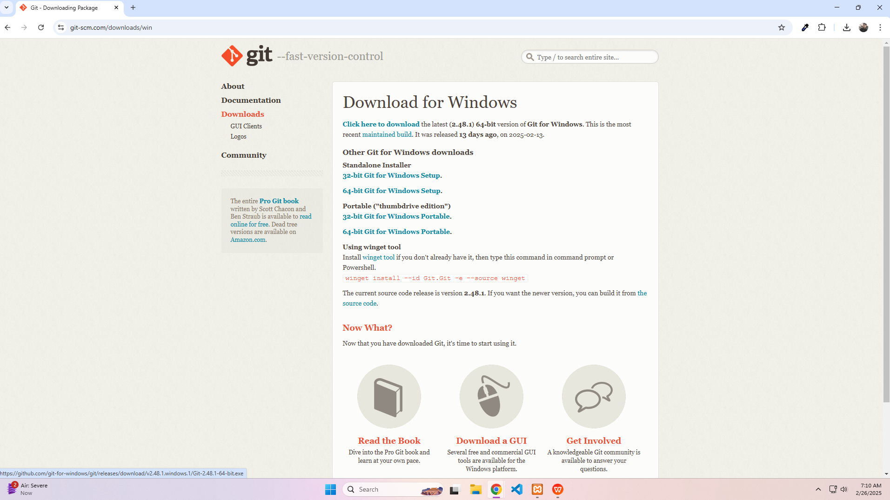

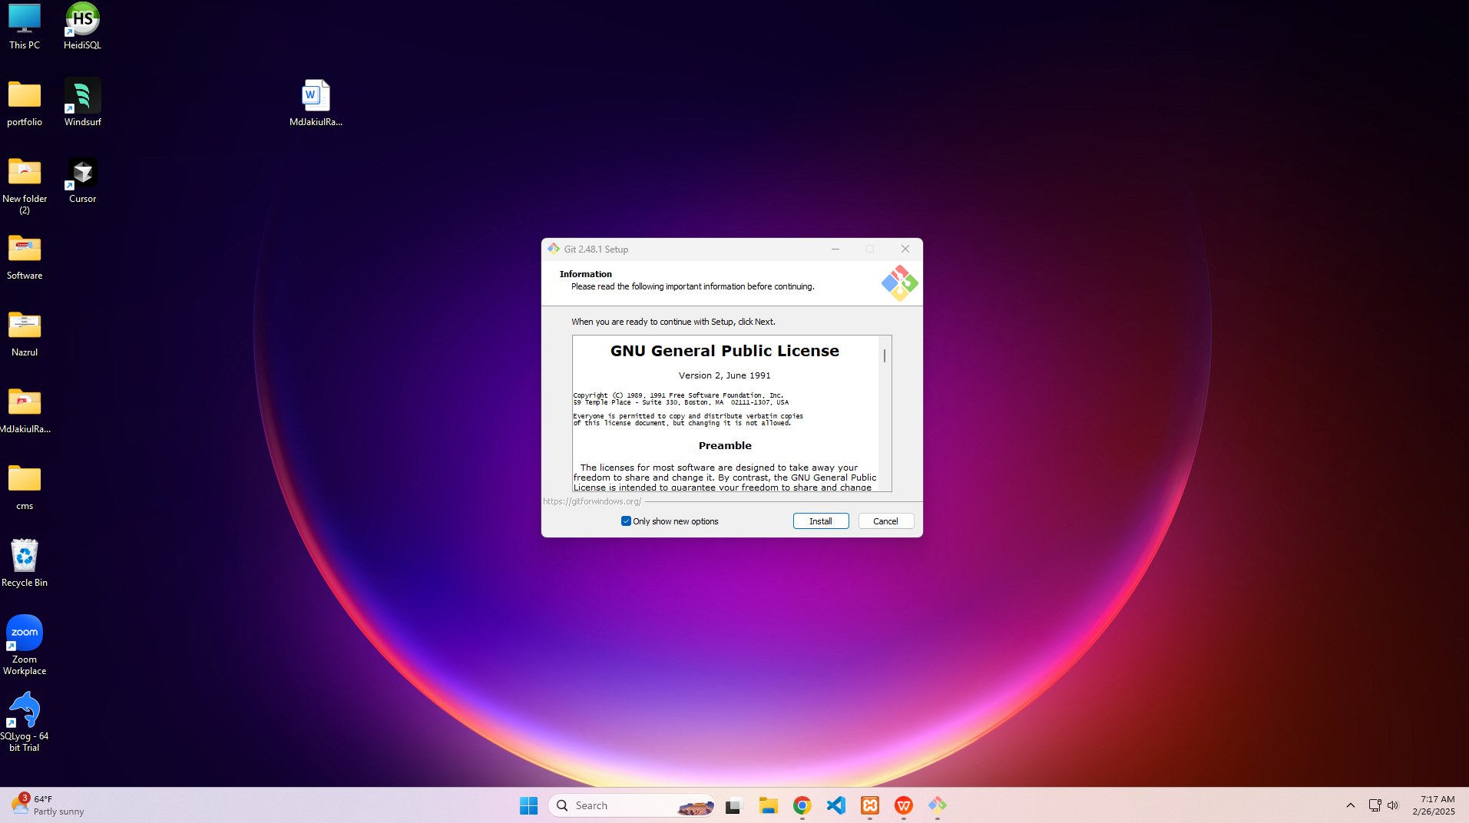

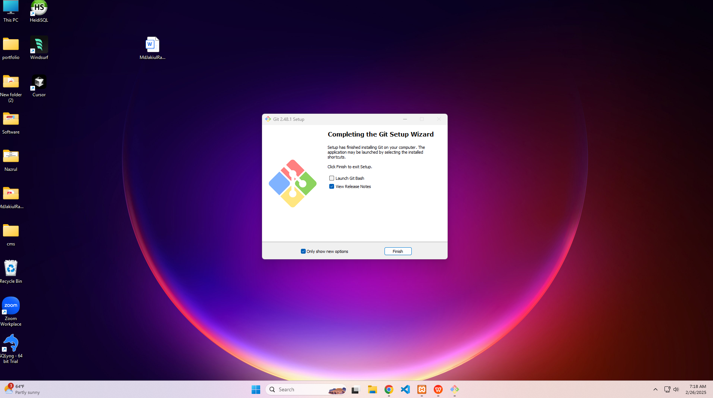

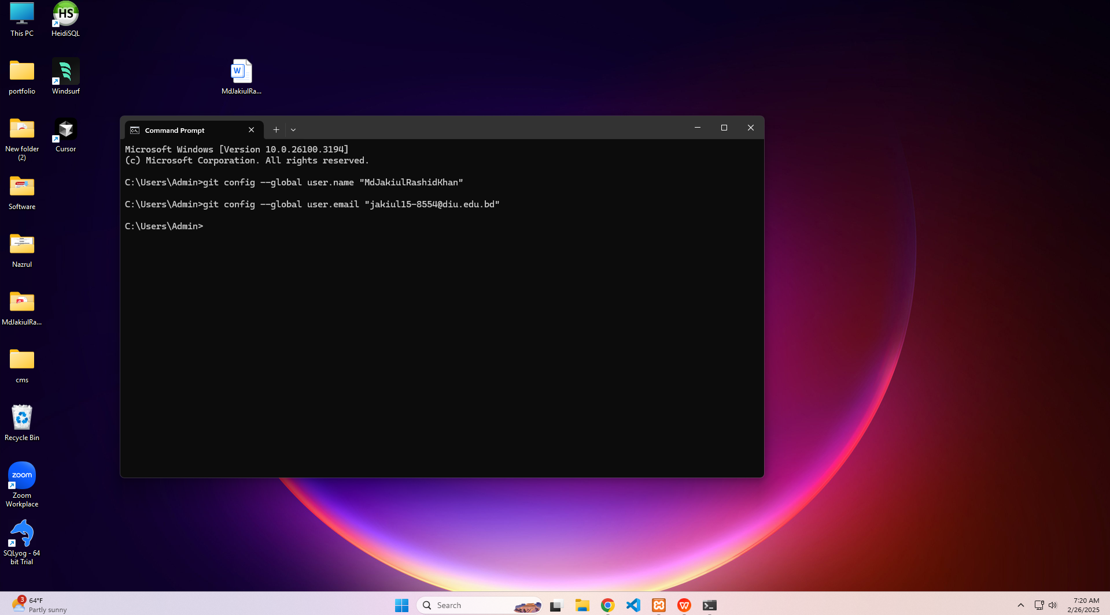

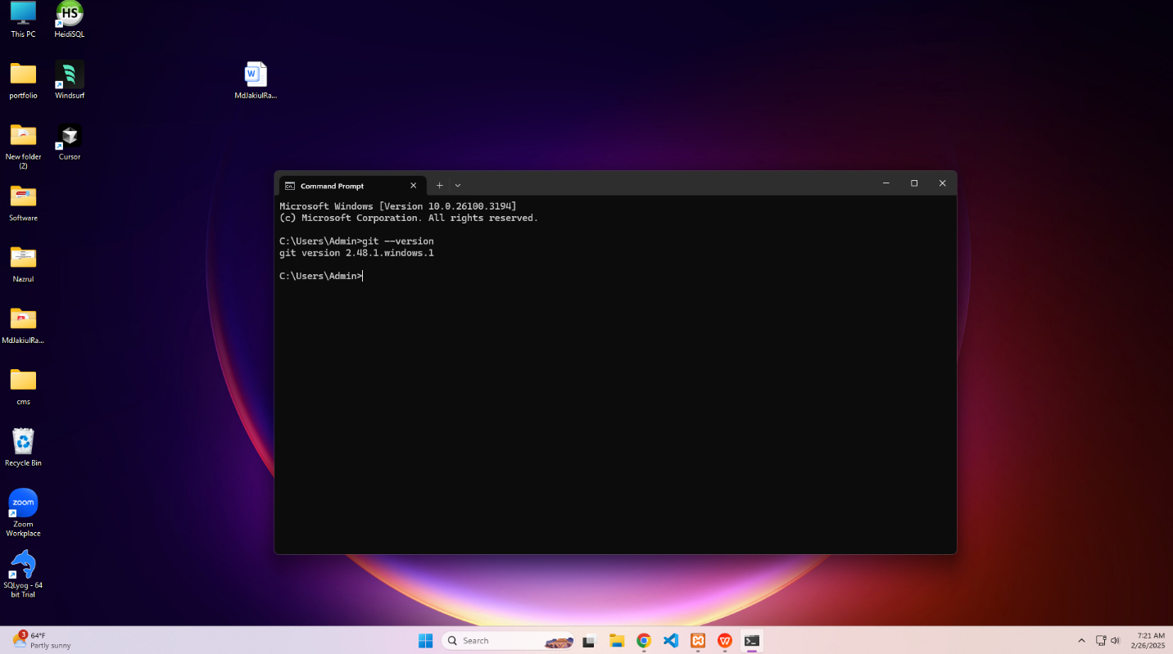

**Step 2: Work with a Git Repository**

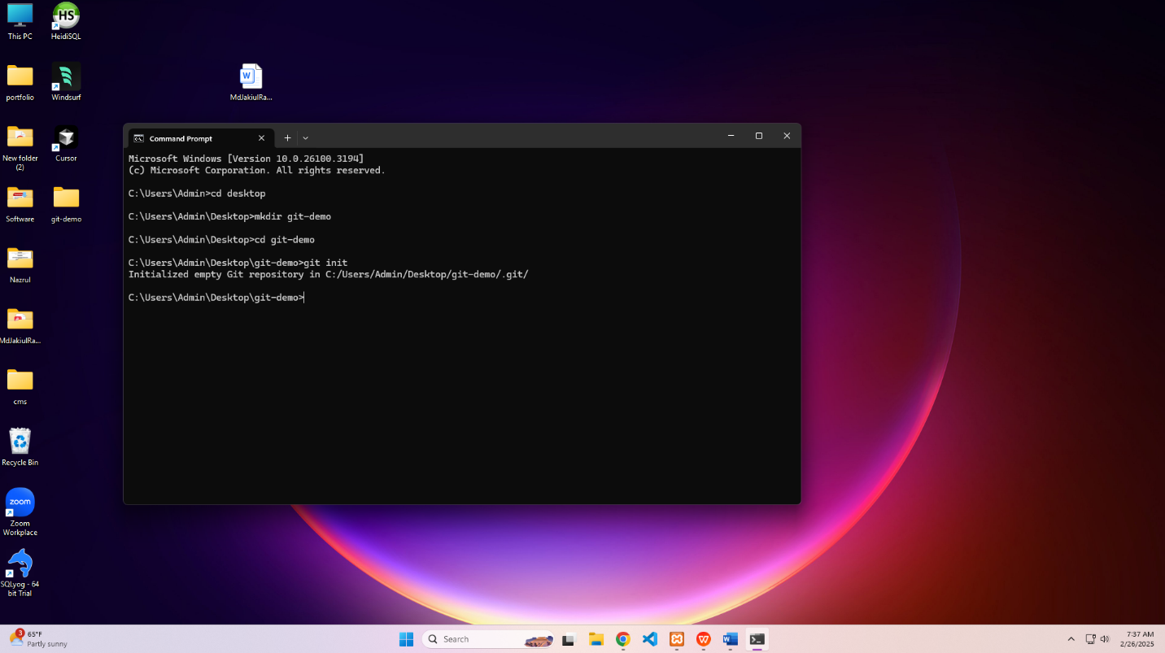

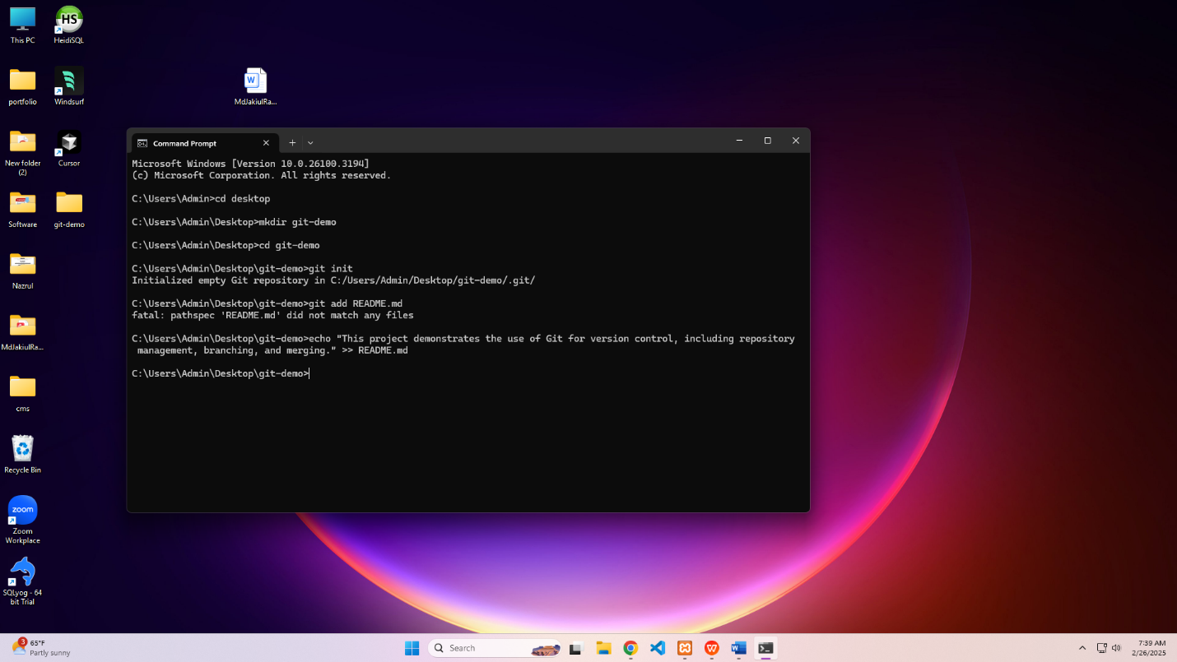

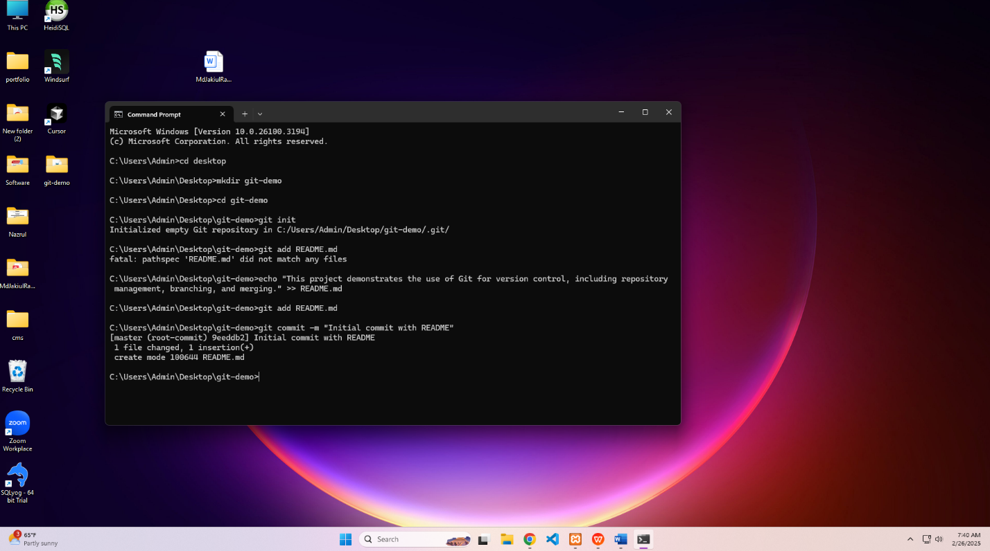

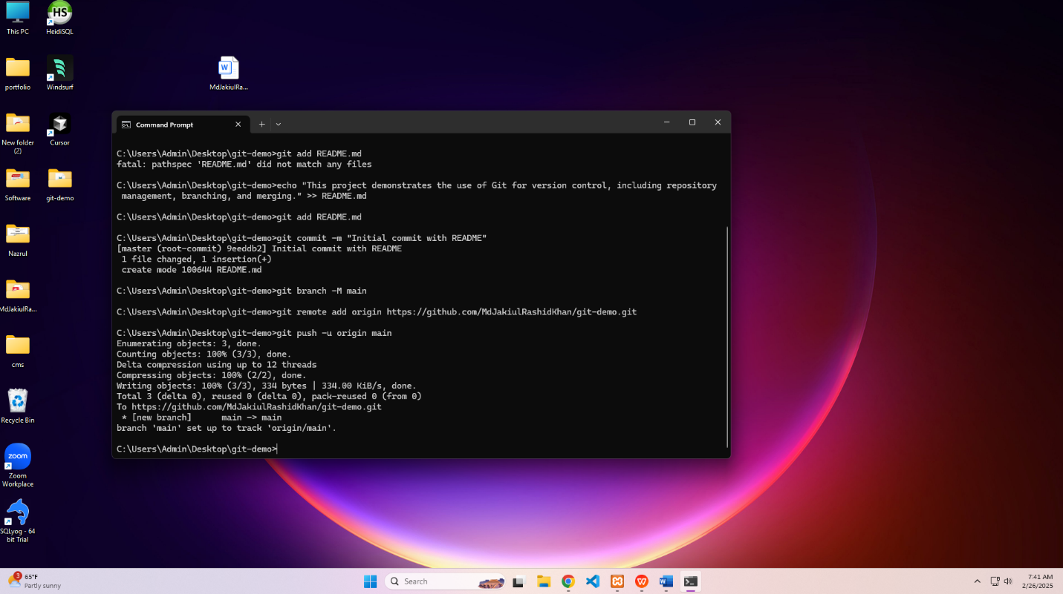

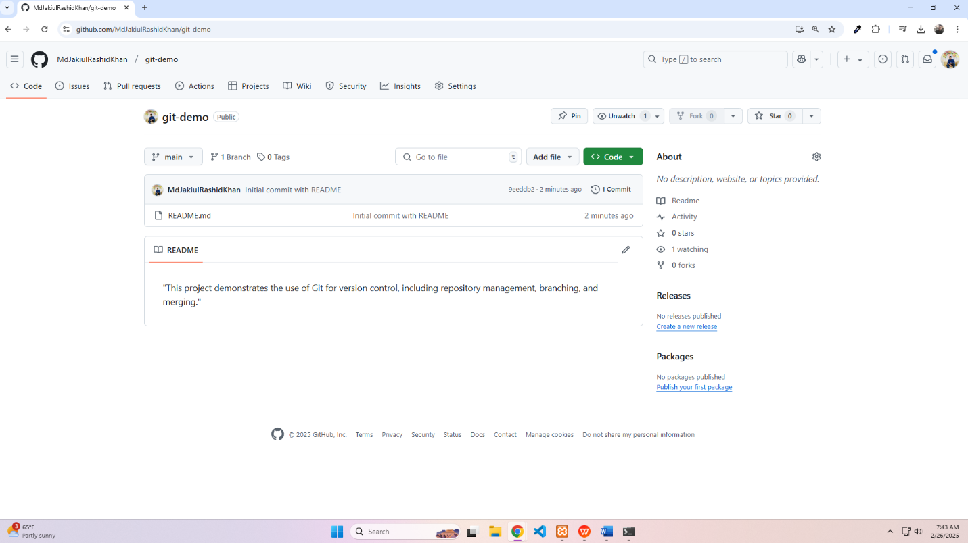

**Step 3: Branching and Merging**

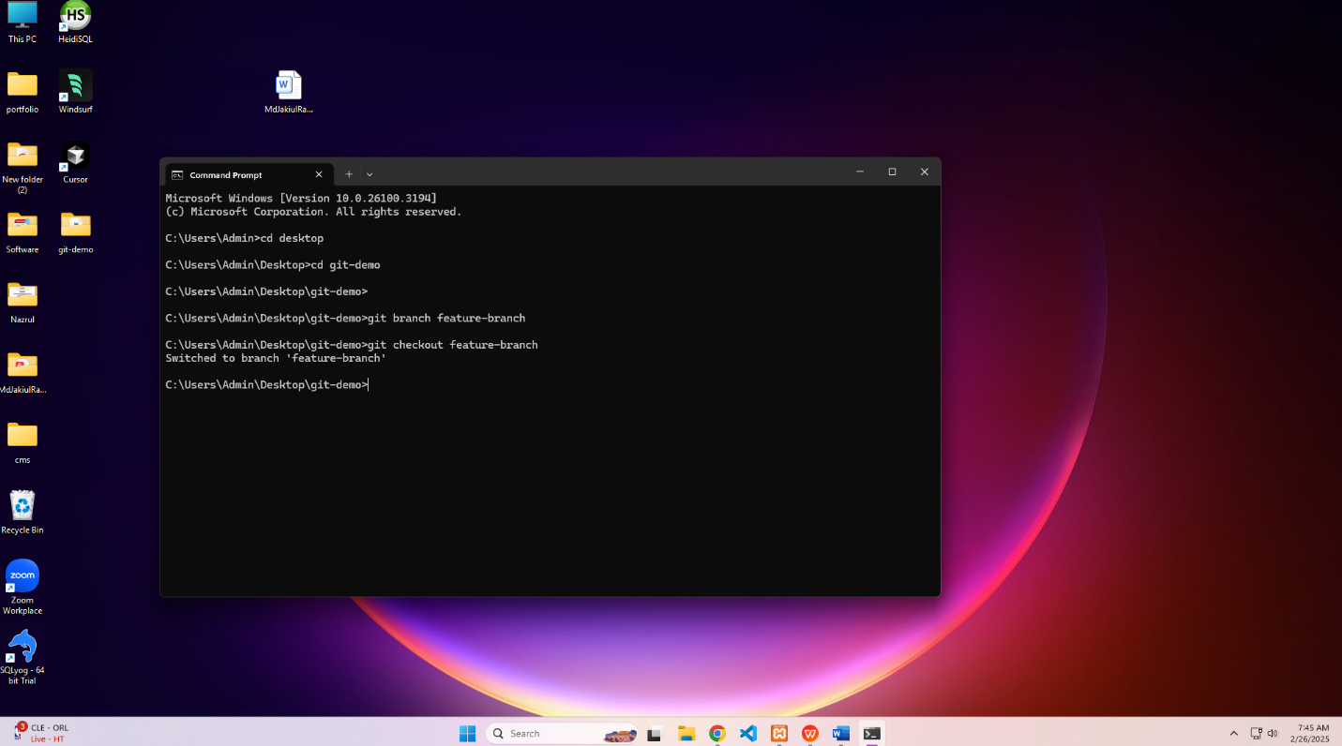

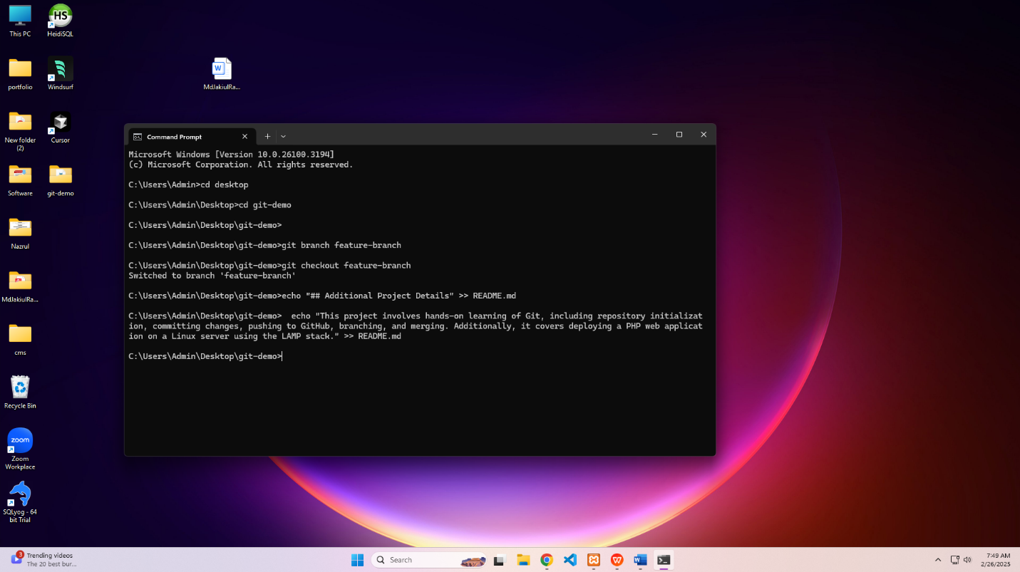

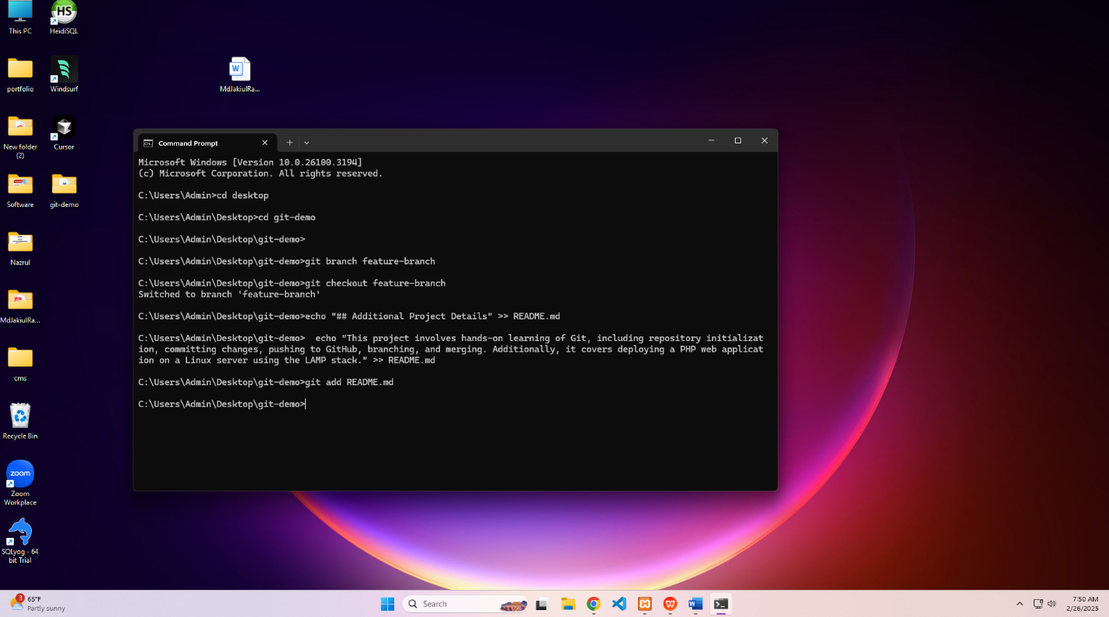

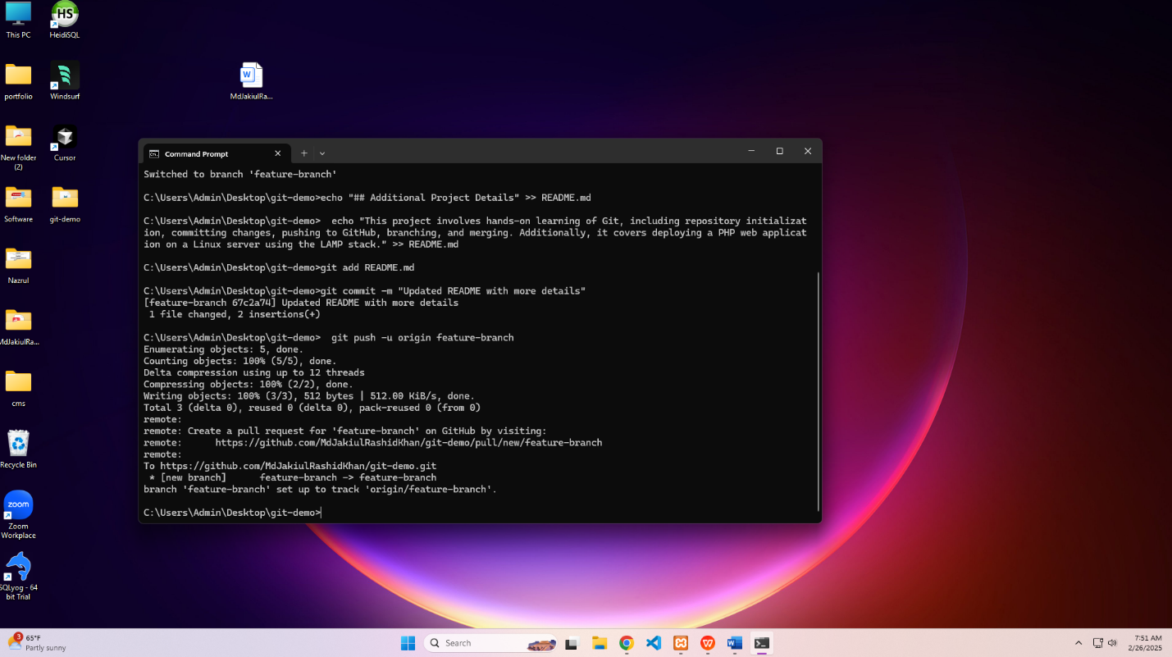

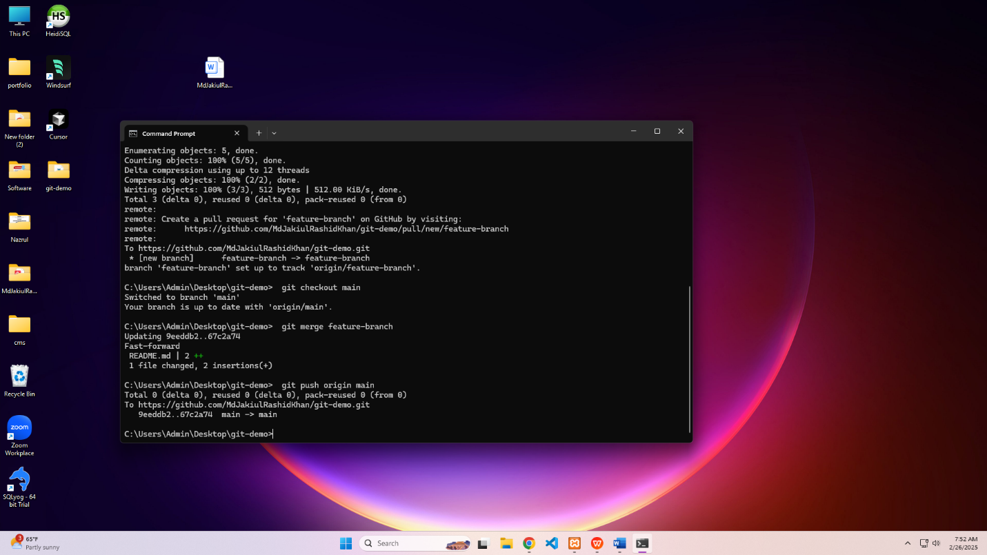

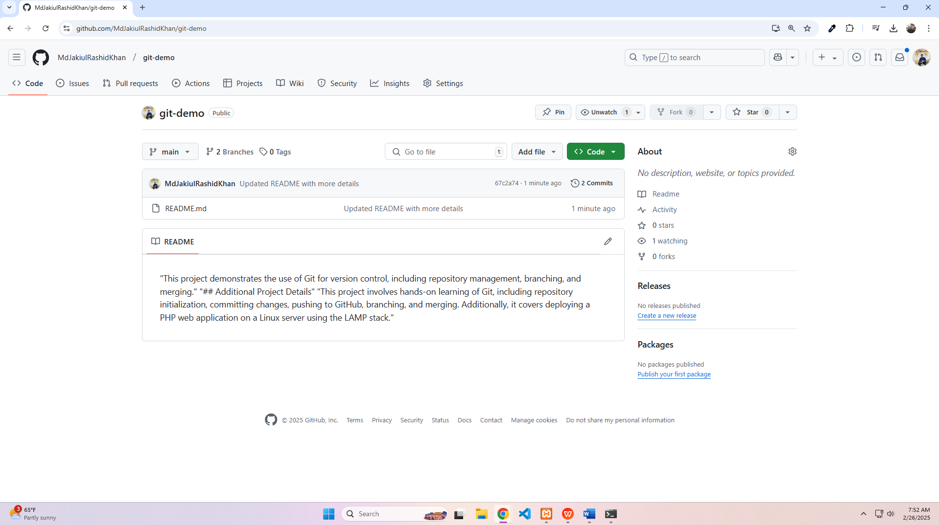

4. **Step 4: Learn About Deployment**

**4.1.** **Steps to deploy a PHP web application on a Linux server**

**1.Set Up a Linux Server**:

* Choose a Linux distribution (e.g., Ubuntu, CentOS).
* Provision a server (e.g., using AWS, DigitalOcean, or any VPS provider).
* SSH into the server and update the system packages:

sudo apt update && sudo apt upgrade -y

**2.Install a Web Server**:

* Install Apache or Nginx (commonly used web servers for PHP applications):

sudo apt install apache2

or, sudo apt install nginx

**Install PHP**:

* Install PHP and necessary extensions:

sudo apt install php libapache2-mod-php php-mysql php-curl php-gd php-mbstring php-xml php-zip

Restart the web server to apply changes:

sudo systemctl restart apache2

or, sudo systemctl restart nginx

**3.Set Up a Database**:

* Install MySQL or MariaDB:

sudo apt install mysql-server

Secure the database installation:

sudo mysql_secure_installation

Create a database and user for your PHP application:

CREATE DATABASE app_db;

CREATE USER 'app_user'@'localhost' IDENTIFIED BY 'password';

GRANT ALL PRIVILEGES ON app_db.* TO 'app_user'@'localhost';

FLUSH PRIVILEGES;

**4.Upload Your PHP Application**:

* Use SCP, SFTP, or Git to upload your PHP application files to the server:

scp -r /path/to/your/app user@server_ip:/var/www/html/

Set the correct permissions:

sudo chown -R www-data:www-data /var/www/html/your_app

sudo chmod -R 755 /var/www/html/your_app

**5.Configure the Web Server**:

* For Apache, create a virtual host configuration file:

sudo nano /etc/apache2/sites-available/your_app.conf

Example configuration:

<VirtualHost *:80>

ServerAdmin webmaster@localhost

DocumentRoot /var/www/html/your_app

ServerName yourdomain.com

<Directory /var/www/html/your_app>

Options Indexes FollowSymLinks

AllowOverride All

Require all granted

</Directory>

ErrorLog ${APACHE_LOG_DIR}/error.log

CustomLog ${APACHE_LOG_DIR}/access.log combined

</VirtualHost>

Enable the site and reload Apache:

sudo a2ensite your_app.conf

sudo systemctl reload apache2

**6.Secure the Application**:

* Install an SSL certificate (e.g., using Let's Encrypt):

sudo apt install certbot python3-certbot-apache

sudo certbot --apache -d yourdomain.com

Configure a firewall (e.g., UFW):

sudo ufw allow 'Apache Full'

sudo ufw enable

**7.Test the Application**:

* + Access your application via a web browser using your domain or server IP.
  + Ensure all functionalities (e.g., database connections, forms) are working correctly.

**8.Monitor and Maintain**:

* + Set up monitoring tools (e.g., Nagios, Prometheus).
  + Regularly update your server and application dependencies.

#### **4.2**. **Benefits of CI/CD (Continuous Integration & Continuous Deployment)**

CI/CD (Continuous Integration and Continuous Deployment) is a set of practices and tools that automate the process of integrating code changes and deploying applications. Here are the key benefits:

1. **Faster Time to Market**:
   * CI/CD automates the build, test, and deployment processes, reducing manual effort and speeding up the release cycle.
   * Developers can push code changes more frequently, enabling faster delivery of features and bug fixes.
2. **Improved Code Quality**:
   * Automated testing in CI pipelines ensures that code changes are validated before being merged, reducing the likelihood of bugs reaching production.
   * Code reviews and static analysis tools can be integrated into the CI process to maintain high code quality.
3. **Reduced Risk**:
   * Smaller, incremental changes are easier to test and debug, reducing the risk of introducing major issues.
   * Automated rollback mechanisms in CD pipelines allow quick recovery in case of deployment failures.
4. **Increased Collaboration**:
   * CI/CD encourages collaboration between development, testing, and operations teams by providing a shared, automated workflow.
   * Developers receive immediate feedback on their changes, fostering a culture of continuous improvement.
5. **Consistency and Reliability**:
   * Automated pipelines ensure that every code change goes through the same process, reducing human error and ensuring consistent deployments.
   * Environments (e.g., staging, production) can be replicated easily, ensuring reliability across different stages.
6. **Cost Efficiency**:
   * Automating repetitive tasks reduces manual effort, saving time and resources.
   * Early detection of issues in the CI pipeline reduces the cost of fixing bugs later in the development cycle.
7. **Scalability**:
   * CI/CD pipelines can handle multiple deployments simultaneously, making it easier to scale applications and infrastructure.
   * Cloud-native CI/CD tools (e.g., Jenkins, GitLab CI, GitHub Actions) integrate seamlessly with modern cloud platforms.
8. **Enhanced Security**:
   * Security checks (e.g., vulnerability scanning, dependency checks) can be integrated into the CI/CD pipeline to identify and address security issues early.
   * Automated deployments reduce the risk of misconfigurations that could lead to security breaches.
9. **Better Customer Satisfaction**:
   * Faster delivery of features and bug fixes leads to a better user experience.
   * Reliable deployments ensure minimal downtime and disruptions for end-users.

By adopting CI/CD, organizations can achieve a more efficient, reliable, and scalable software development lifecycle, ultimately delivering higher-quality software to their users.